**Revised Plan:**

1. 3D design: frame + propellers (Dmytro)

**Quadrocopter frame -**  [Quadcopter frame (drone w/ 4 motor) by ejdzey | Download free STL model | Printables.com](https://www.printables.com/model/681241-quadcopter-frame-drone-w-4-motor)

**Frame with Motor Enclosure** - <https://www.printables.com/model/205565-mini-drone-frame-8mm-motors>

**Frame for 9’’ propellers** - <https://www.printables.com/model/387178-fully-printed-quadcopterdrone-frame-for-9-propelle>  
**Tri-blade Toroidal Propellers** - <https://www.printables.com/model/393972-v3-tri-loop-or-tri-blade-toroidal-propellers-for-f>.

**Weight to carry:** <https://www.unmannedsystemstechnology.com/feature/calculating-how-much-weight-a-drone-can-carry/#:~:text=Drone%20Carrying%20Capacity&text=Let's%20assume%20we%20want%20our,weigh%2040%20kg%20in%20total.&text=We%20figure%20out%20that%20we,is%2020%20kgf%20per%20propeller>.

5inch Drone: <https://www.youtube.com/watch?v=ZaBlsTkxKIM&ab_channel=TRONCATFPV>

| **Component** | **Weight (g)** | **Voltage (V)** | **Price** | **Quantity** | **Source** | **Important parameters** |
| --- | --- | --- | --- | --- | --- | --- |
|  |  |  |  |  |  |  |
| Frame:  TBS Sourcecode V5 | 123.5 g | N/A | 47$ | 1 | <https://rotorvillage.ca/tbs-source-one-v5-5/> | 1. Stack mounting: 30.5mm x 30.5 mm;  2. Motor dimensions  3. Little space at the bottom to extend servo motor wires. |
| Flight Controller +ESC: SpeedyBee F405 | 9.6g | 3S-6S | 50$ | 1 | <https://rotorvillage.ca/speedybee-f405-v3-30x30-flight-controller/> | 1. A datasheet with all required parameters  2. Has extra UART connections, potential use for servo motor (3.3V output) 3. SDA&SLCK  4. Same mounting as on the frame 5.COMING TOGETHER WITH ESC - SpeedyBee BLC 50A 4-in-1 ESC  6. Kit has extra parts for assembly (power cable, capacitor, DJI cable) |
| Motor:  T-Motor Velox V3 2550KV | 37.3gx4=150g | 6s | 81$ | 4 | <https://rotorvillage.ca/t-motor-velox-v3-2207-1750-1950-2550kv-motor/> | 1. Compatibility with battery (6s)  2. Idle current: 1.28A 3. Peak Current (1 min): 34.6A |
| Video Transmitter:  Happymodel OVX300 | 0.9g | 5V | 30$ | 1 | <https://rotorvillage.ca/happymodel-ovx300-25-300mw-5-8ghz-u-fl-vtx-w-openvtx/> | OPTIONAL ; |
| HAPPYMO.,; DEL EXPRESSLRS EP1 2.4GHZ RX | 0.5g (without antenna) | 5V | 20$ | 1 | <https://rotorvillage.ca/happymodel-expresslrs-ep1-2-4ghz-rx/> | Not from the video,  1. |
|  |  |  |  |  |  |  |
|  |  |  |  |  |  |  |
|  |  |  |  |  |  |  |
|  |  |  |  |  |  |  |

1. Parts List: Power Distributor, Flight Control → ESD, Rec, Antenna, MOTORS (Randy, Van)

Website: <https://www.quadpartpicker.com/builder>

**THIS LIST IS NOT CONFIRMED FOR COMPATIBILITY**

**Receiver** - <https://rotorvillage.ca/hglrc-elrs-2-4g-receiver/>

**Antenna** - <https://rotorvillage.ca/radiomaster-2-4ghz-t-antenna-65mm/>

**Motor** - <https://rotorvillage.ca/geprc-em2807-1350kv-motor/>

<https://rotorvillage.ca/geprc-speedx2-1303-5-5500kv-motor/>

**Battery** - <https://rotorvillage.ca/gnb-550mah-1s-90c-lipo-a30/>

**FPV Camera** - <https://rotorvillage.ca/runcam-atom-w-ultra-nano-fpv-camera/>

**Flight Controller** - <https://rotorvillage.ca/speedybee-f405-v3-30x30-flight-controller/>

**Speed Controller** - <https://www.amazon.ca/QWinOut-Brushless-Controller-Multicopter-Quadcopter/dp/B07SFLJJQ5/ref=pd_bxgy_d_sccl_2/141-2223000-7770910?pd_rd_w=U9f3D&content-id=amzn1.sym.93ae3f3f-3555-4971-a952-df8053b1d375&pf_rd_p=93ae3f3f-3555-4971-a952-df8053b1d375&pf_rd_r=AY6G5YDNSQF8X3YK5H0M&pd_rd_wg=mlUCc&pd_rd_r=78332ab5-309c-4651-97e1-a158ac2f7520&pd_rd_i=B07SFLJJQ5&th=1>

**Power Distribution Panel - ???**

| **Component** | **Weight (g)** | **Voltage (V)** | **Price** | **Quantity** |
| --- | --- | --- | --- | --- |
| Frame | 200g | N/A | ??? | 1 |
| Propeller | 50g | N/A | ??? | 4 |
| Receiver:  TBS Crossfire Nano RX Pro | 0.5g | 3.3V-8.4V | $34.99 | 1 |
| Antenna:  TBS Crossfire Immortal T Antenna V2 | 4g | N/A | $5.99 | 2 |
| Motor:  Velox V2808 Cinematic Motor 1500KV | 60.5g | 25.2V | $27.99 | 4 |
| Battery:  Tattu R-Line 1400mAh | 222g | 22.2V (6 cell) | $40.99 | 1 |
| FPV Camera:  RunCam Phoenix 2 | 9g | 5-36V | $40 | 1 |
| Flight Controller:  Velox F7 Cine HD | 9.24g | 7.4-17.6V | $85  **(Different model on Quad Part Picker)** | 1 |
| Speed Controller:  Velox V50a 4-in1 ESC | 18.5g | 10-27V | $81  **($60.90 on Quad Part Picker)** | 1 |
| Power Distribution Panel? | ??? | ??? | ??? |  |

Build List on QuadPartPicker:

FPV Cameras - RunCam Phoenix 2 Micro FPV Camera

LiPo / LiHV Batteries - Tattu R-Line Version 5.0 1400mAh 6S 22.2V 150C LiPo Battery - XT60

Flight Controllers - T-Motor VELOX F411 Lite 20x20 / 30x30 Flight Controller **(DIFF)**

**Propellers - Gemfan Cinelifter 7035 7x3.5x3 Tri-Blade 7" Prop* (Optional)**

**Frames - Hyperlite Glide 7" Freestyle Frame* (Optional)**

Antennas - TBS Crossfire Immortal T Extra Extended Antenna V2

Receivers - TBS Crossfire Nano RX PRO Long Range Receiver

Motors - T-Motor VELOX V2808 Motor - 1500Kv

ESCs - T-Motor VELOX V50A 32Bit 50A 3-6S 30x30 4in1 ESC

<https://www.quadpartpicker.com/lists/clrvi5pp9005l2j1amn1i1zxc>

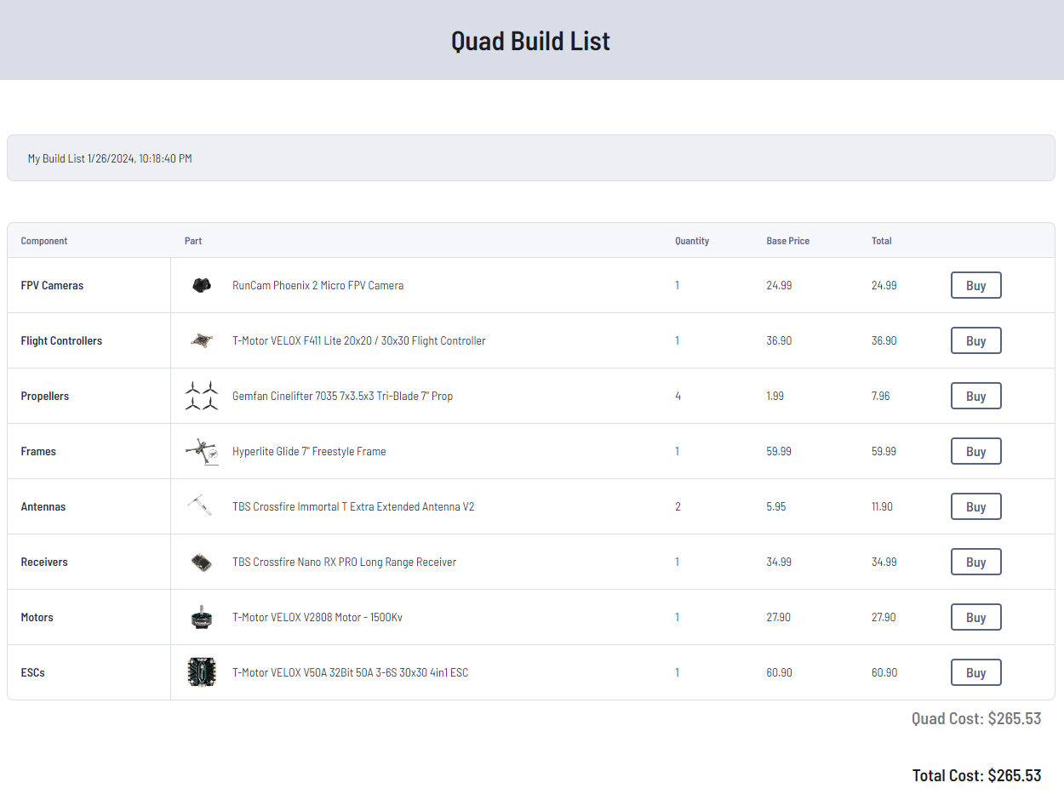

1. Grasper system (Abraar)

- **Hook + Rope (Limitation) (winch system)**

-

- Dynamic Grasping: <https://www.youtube.com/watch?v=mqbj8mEyCdk&ab_channel=MITSPARKLab>

- Magnetic (Limitation)   
 - Soft Robotic hand: <https://www.youtube.com/watch?v=Vpa33EhN3R8&ab_channel=mleko5procent>  
 - **3D printed soft robot gripper**: <https://www.youtube.com/watch?v=1GvSPzWagaM&ab_channel=XYZAidan>

- Retractable system: <https://youtu.be/oXhh4NdWue0>

- Mechanical Grasping:

<https://youtu.be/HrISGcZqgPs>

grasper file link : <https://www.instructables.com/Print-in-Place-Robotic-Gripper/>

<https://www.youtube.com/watch?v=93u8R_UpoCw>

**Hierarchy of grippers:**

1. **Soft robot gripper (3d print)**
2. **Winch system**
3. **Box compartment**
4. Software:

* Block diagram
* Types of Protocols
* Grasper Diagram

1. Revised project plan:
2. schedule, scope, milestone
3. responsibilities/tasks
4. flow charts, tables (bill of materials)
5. block diagrams

-new hardware diagram (new components)

-new software diagram

-gripper system diagram

1. schematics

- design of drone, gripper/winch system

1. technical specifications

- communication protocols (how they work)

- weight, size, voltage, power, price, compatibility, etc.

1. comments/any changes made

6. Milestone 1

1. **Scope** - from a capstone project plane (Dmytro)
2. **Resources** - useful info (Dmytro)
3. **Schedule/ Responsibilities** - create a table

(Initialization: research components, gather info about FPV; Iteration 1: assemble + test; Iteration 2: final product, Close-up: documentation) (Randy) - DONE

* Responsibility (Randy) - DONE
* Hardware (Dmytro)
* Software (Dmytro)
* Drone diagram (Randy) - DONE
* Technical specification (Jason)
* Grasper system (Abraar)

1. **Diagrams:**

* Hardware (Dmytro): provide a communication protocol between components, how components operate between each other. ADD: grasper system
* Software (Dmytro): flow-chart of the components
* Drone diagram (Randy): components + frame - DONE
* Grasper (Abraar): mechanical design, electrical specification, demo, etc
* Components Specification (Jason): all electronics specification (together with Bill list)

We did:

* Purchased following components:
  + Frame
  + Motors (x4)
  + FC +ESC
  + Receiver
  + Battery (battery strap)
  + **ESC not purchased**

Custom builds: <https://rotorbuilds.com/search/tbs+source+one+v5>

Video: <https://www.youtube.com/watch?v=61zLUlE7jUU&t=353s>

To do:

* Propellers (3d printed or TDU plastic) (Buy online, research based on the weight of the drone and weight of the pick-up object, Jason)
* Remote controller (control by phone) (Randy, YouTube, can we???)
* Grasper system (Servo motor + 3d printed claw) (Abraar)
* DJI Air Unit (can it be connected to the drone and controlled by phone) (Dmytro)
* <https://www.youtube.com/watch?v=dfKr32bA4kc>
* <https://www.youtube.com/watch?v=Az5G4nq8F3M>